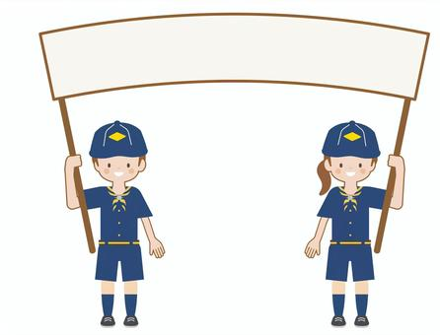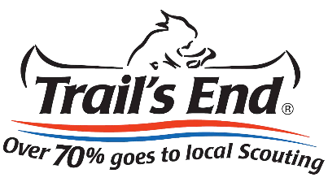

Sorry,

we

missed

you!

**Hi Neighbor!**

**My name is___________ from local Scout Unit __________. I’m fundraising to support local Scouting programs and activities. You can help by purchasing our delicious popcorn online or by contacting a local Scout. Thank you for supporting my Scouting Adventures!**

*Sorry, we missed you!*

**Hi Neighbor!**

**My name is___________ from local Scout Unit __________. I’m fundraising to support local Scouting programs and activities. You can help by purchasing our delicious popcorn online or by contacting a local Scout. Thank you for supporting my Scouting Adventures!**

**SCOUTS**

**SCOUTS**

**YOUR LOCAL**

**YOUR LOCAL**

**SUPPORT**

**SUPPORT**

Prefer Local Scout Delivery? Call ____________

Online Order Use Scout Code: ______________

Prefer Local Scout Delivery? Call ____________

Online Order Use Scout Code: ______________

*Contact a local Scout or Check Online for the Product Lineup*

*Contact a local Scout or Check Online for the Product Lineup*

**trails-end.com**

**ORDER ONLINE**

**trails-end.com**

**ORDER ONLINE**